**State Placement Test Notice for selected 9th graders**

September 16th & 17th

8:30 AM

Per the Board of Elementary and Secondary Education Policy (Bulletin 1566), students shall be required to take the English language arts and mathematics portions of the state placement test **if they enroll as 9th graders from any:**

* **in-state nonpublic school**
* **approved home study program**
* **out-of-state school**

This test is a computer-based test that is designed to measure students’ knowledge and skills in ELA and math pursuant to Louisiana Student Standards in grade 8. The test is consistent with the LEAP 2025 test taken by students enrolled in Louisiana public schools and results will be available within two weeks of completion. The information gained from these results will be shared with you and we will use them to support your student academically this year and in the future.

**Performance on these tests will NOT impact their enrollment or placement at Byrd High School.**

**All testing will begin at 8:30**

**The selected students will receive individual notices**

**Students will be assigned to a computer lab.**

**All work missed can be made up without penalty.**

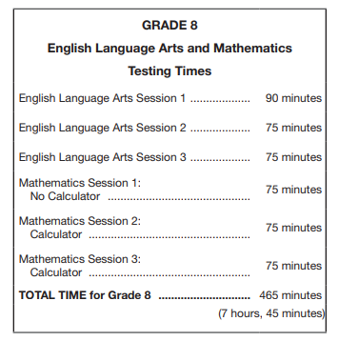

**If you have any questions regarding this process, please contact**

**Lisa Johnson,**

**Assistant Principal at** [**lwjohnson@caddoschools.org**](mailto:lwjohnson@caddoschools.org) **or at 364-5462.**